

National Textile University
Department of Computer Science
Subject: Operating System

Submitted to: Sir Nasir

Submitted by: Maha

Reg. number: 23-NTU-CS-1170
Lab 9 (class task)
Semester:5th

Code:
#include <stdio.h>
#include <pthread.h>
#include <semaphore.h>
#include <unistd.h>
sem_t mutex; // Binary semaphore
int counter = 0;
void* thread_function(void* arg) {
int id = *(int*)arg;
for (int i = 0; i < 5; i++) {
printf("Thread %d: Waiting...\n", id);
sem_wait(&mutex); // Acquire
// Critical section
counter++;
printf("Thread %d: In critical section | Counter = %d\n", id,
counter);
sleep(1);
sem_post(&mutex); // Release
sleep(1);
}
return NULL;
}
int main() {
sem_init(&mutex, 0, 1); // Binary semaphore initialized to 1
pthread_t t1, t2;
int id1 = 1, id2 = 2;
pthread_create(&t1, NULL, thread_function, &id1);
pthread_create(&t2, NULL, thread_function, &id2);
pthread_join(t1, NULL);
pthread_join(t2, NULL);
printf("Final Counter Value: %d\n", counter);
sem_destroy(&mutex);
return 0;
}

Terminal:
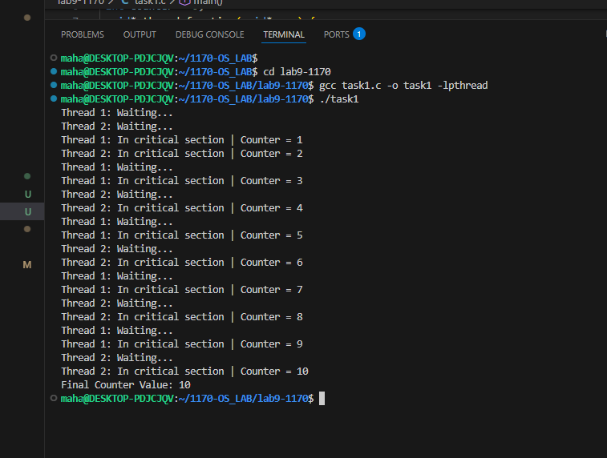

Task2
Update the semaphore values from 0,1 to 0,0 making both threads wait
Code:
#include <stdio.h>
#include <pthread.h>
#include <semaphore.h>
#include <unistd.h>
sem_t mutex; // Binary semaphore
int counter = 0;
void* thread_function(void* arg) {
int id = *(int*)arg;
for (int i = 0; i < 5; i++) {
printf("Thread %d: Waiting...\n", id);
sem_wait(&mutex); // Acquire
// Critical section
counter++;
printf("Thread %d: In critical section | Counter = %d\n", id,
counter);
sleep(1);
sem_post(&mutex); // Release
sleep(1);
}
return NULL;
}
int main() {
sem_init(&mutex, 0, 0); // Binary semaphore initialized to 1
pthread_t t1, t2;
int id1 = 1, id2 = 2;
pthread_create(&t1, NULL, thread_function, &id1);
pthread_create(&t2, NULL, thread_function, &id2);
pthread_join(t1, NULL);
pthread_join(t2, NULL);
printf("Final Counter Value: %d\n", counter);
sem_destroy(&mutex);
return 0;
}

Terminal:
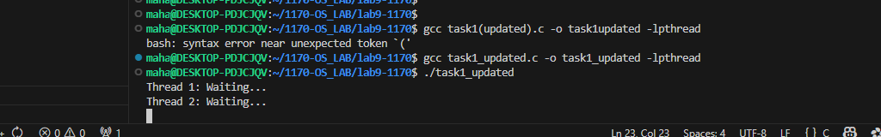
Reminders:
- Both threads want to go in critical section
- But both are waiting
- And blocked
Task3:
Code:
#include <stdio.h>
#include <pthread.h>
#include <semaphore.h>
#include <unistd.h>
sem_t mutex; // Binary semaphore
int counter = 0;
void* thread_function(void* arg) {
int id = *(int*)arg;
for (int i = 0; i < 5; i++) {
printf("Thread %d: Waiting...\n", id);
// sem_wait(&mutex); // Acquire
// Critical section
counter++;
printf("Thread %d: In critical section | Counter = %d\n", id,
counter);
sleep(1);
sem_post(&mutex); // Release
sleep(1);
}
return NULL;
}
int main() {
sem_init(&mutex, 0, 0); // Binary semaphore initialized to 1
pthread_t t1, t2;
int id1 = 1, id2 = 2;
pthread_create(&t1, NULL, thread_function, &id1);
pthread_create(&t2, NULL, thread_function, &id2);
pthread_join(t1, NULL);
pthread_join(t2, NULL);
printf("Final Counter Value: %d\n", counter);
sem_destroy(&mutex);
return 0;
}

Terminal:
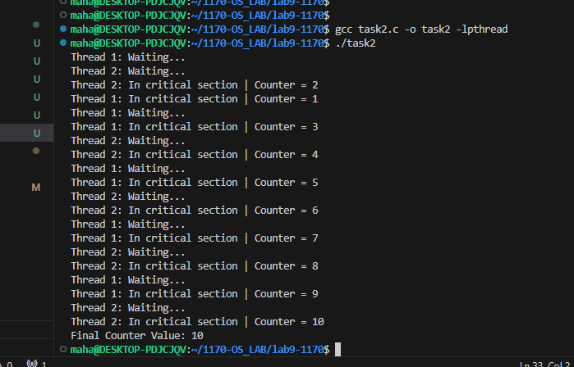
Task4:
Code:
#include <stdio.h>
#include <pthread.h>
#include <semaphore.h>
#include <unistd.h>
sem_t mutex; // Binary semaphore
int counter = 0;
void* thread_function(void* arg) {
int id = (int)arg;
for (int i = 0; i < 5; i++) {
printf("Thread %d: Waiting...\n", id);
sem_wait(&mutex); // Acquire
// Critical section
counter++;
printf("Thread %d: In critical section | Counter = %d\n", id,
counter);
sleep(1);
//sem_post(&mutex); // Release
sleep(1);
}
return NULL;
}
int main() {
sem_init(&mutex, 0, 1); // Binary semaphore initialized to 1
pthread_t t1, t2;
int id1 = 1, id2 = 2;
pthread_create(&t1, NULL, thread_function, &id1);
pthread_create(&t2, NULL, thread_function, &id2);
pthread_join(t1, NULL);
pthread_join(t2, NULL);
printf("Final Counter Value: %d\n", counter);
sem_destroy(&mutex);
return 0;
}

Terminal:


Task2:
Code:
#include <stdio.h>
#include <pthread.h>
#include <semaphore.h>
#include <unistd.h>
sem_t mutex; // Binary semaphore
int counter = 0;

void* thread_increament(void* arg) {
int id = (int)arg;
for (int i = 0; i < 5; i++) {
printf("Thread %d: Waiting...\n", id);
sem_wait(&mutex); // Acquire
// Critical section
counter++;
printf("Thread %d: In critical section | Counter = %d\n", id,
counter);
sleep(1);
sem_post(&mutex); // Release
sleep(1);
}
return NULL;
}

void* thread_decrement(void* arg) {
int id = (int)arg;
for (int i = 0; i < 5; i++) {
printf("Thread %d: Waiting...\n", id);
sem_wait(&mutex); // Acquire
// Critical section
counter--;
printf("Thread %d: In critical section | Counter = %d\n", id,
counter);
sleep(1);
sem_post(&mutex); // Release
sleep(1);
}
return NULL;
}

int main() {
sem_init(&mutex, 0, 1); // Binary semaphore initialized to 1
pthread_t t1, t2;
int id1 = 1, id2 = 2;
pthread_create(&t1, NULL, thread_increament, &id1);
pthread_create(&t2, NULL, thread_decrement, &id2);
pthread_join(t1, NULL);
pthread_join(t2, NULL);
printf("Final Counter Value: %d\n", counter);
sem_destroy(&mutex);
return 0;
}

Terminal:
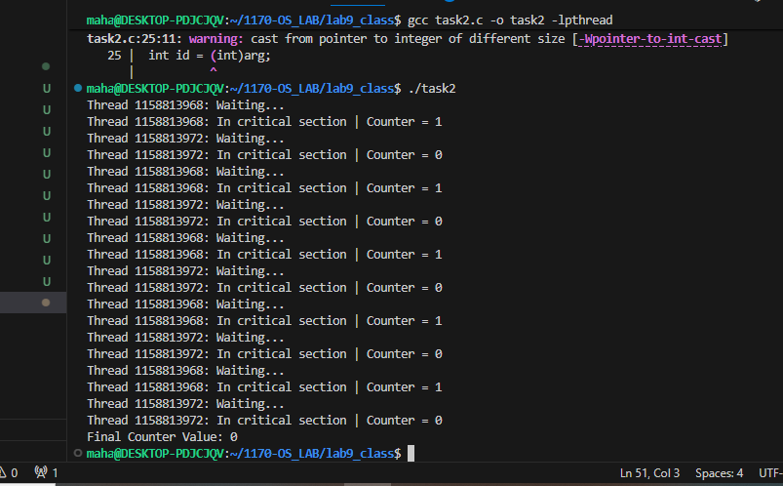
Difference between mutex and semaphore:
Feature | Semaphore | Mutex
Type | Signaling mechanism | Locking mechanism
Value | Can be 0, 1, or more (binary or counting) | Always 1 (binary lock)
Ownership | No ownership — any thread can wait or signal | Owned by the thread that locks it; only owner should unlock
Usage | Controls access count to a resource | Ensures exclusive access to a resource
Deadlock risk | Lower (no ownership rules) | Higher if a thread forgets to unlock
Kernel involvement | Often supports signaling between processes | Usually thread-specific
Multiple resources? | Yes, counting semaphore can allow N threads at once | No, only one thread can own mutex

Similarities:
Both are used for synchronization:
- Prevent race conditions
- Protect shared resources
- Manage access when multiple threads/processes run in parallel
- Provide blocking (wait) and releasing mechanisms

Where to use:
Feature / Scenario | Semaphore (Binary or Counting) | Mutex (Binary Lock)
Primary Purpose | Signaling & controlling access count | Exclusive locking (mutual exclusion)
When to Use | When multiple threads may access a resource (counting) OR for thread-to-thread signaling (binary) | When only ONE thread must access a resource at a time
Resource Type | Pools, shared buffers, limited resources | Single shared resource requiring strict protection
Ownership | No ownership — can be released by any thread | Owned by the thread that locks it
Allows Multiple Threads? | Yes (counting semaphore allows N threads) | No, only 1 thread at a time
Typical Use Cases | Producer–consumer, connection pools, print queue, event signaling | Shared variables, file writing, critical sections
Inter-process Use | Can synchronize different processes | Usually thread-level only
Deadlock Risk | Lower (but still possible) | Higher if a thread forgets to unlock
Signaling Between Threads | Yes — used for notifications | Not used for signaling, only locking
Initialization Value | Can be > 1 | Always starts at 1

